9.21

Consider the following page reference string: 7, 2, 3, 1, 2, 5, 3, 4, 6, 7, 7, 1, 0, 5, 4, 6, 2, 3, 0 , 1.

Assuming demand paging with three frames, how many page faults would occur for the following replacement algorithms?

LRU replacement

FIFO replacement

Optimal replacement

Answer:

18

17

13

9.30

a.

i. Initial value of the counters--0

ii. Counters are increased--when a new page is associated with that frame.

iii. Counters are decreased--when one of the pages associated with the frame is no longer required.

iv. By using FIFO for breaking ties to find a frame with the smallest counter.

b. 14 page faults

c. 11 page faults

Compile the files, and enter “java Test 8 [1,9] ”, then we can get these groups of data.

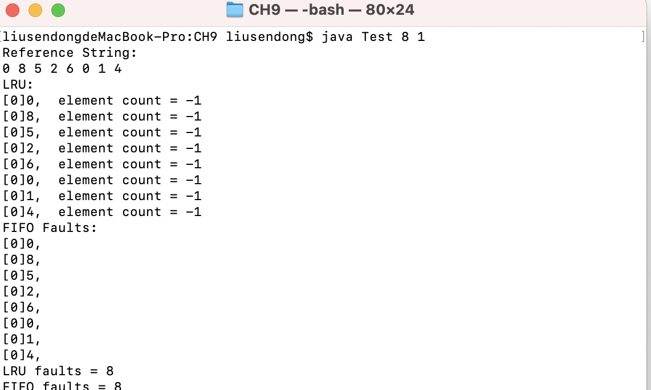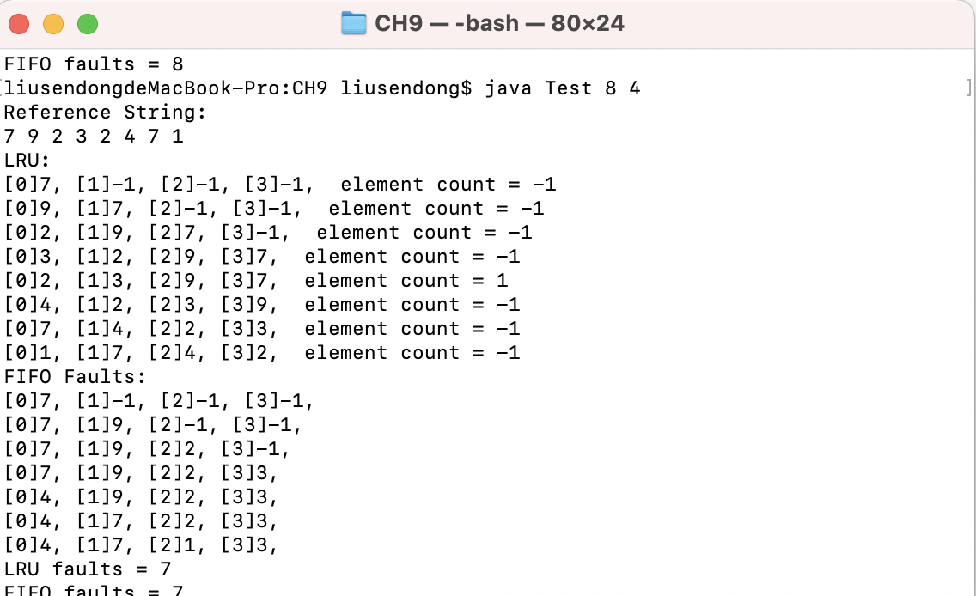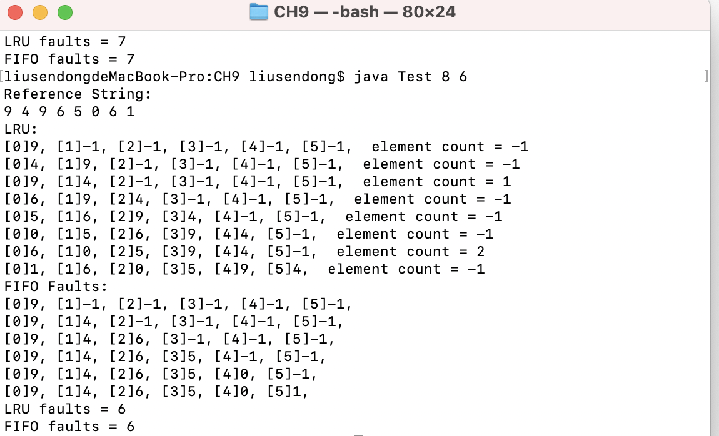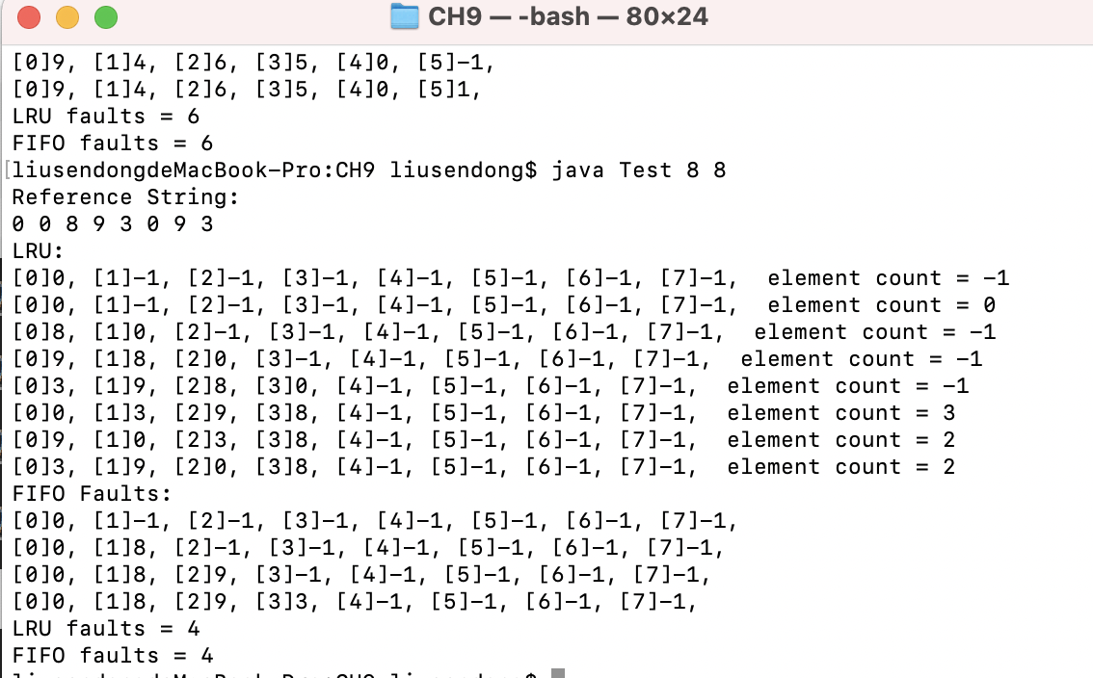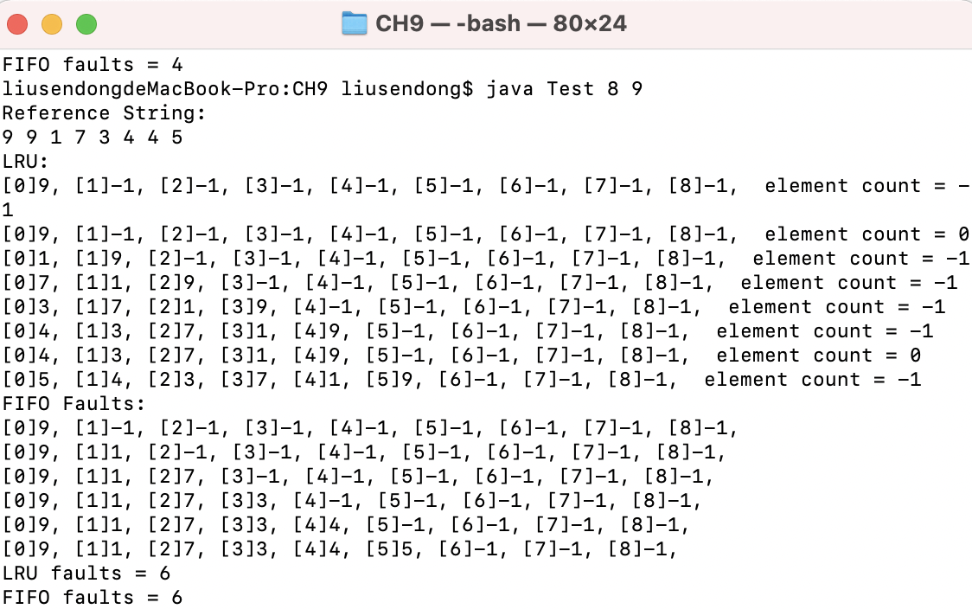

We can see LRU and FIFO faults reach at the least at Page numbers = 8;

When Page numbers = 9, faults = 6 because of Belady's Anomaly.